Artificial Intelligence (Lab)


Lab-05

Submitted by:
Hafiza Nishwa Jamil

Roll No:
BSSE-4A-S25-046

Submitted to:
Sir Rasikh Ali

Task-01:
Trace the supplied tree by hand using Minimax.
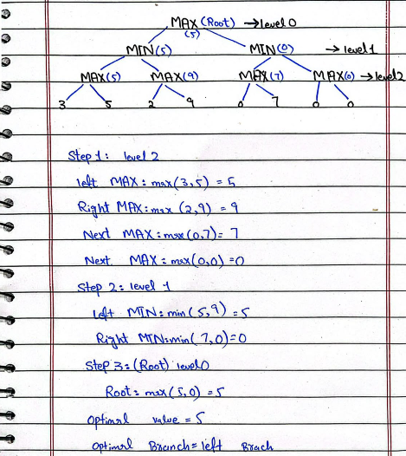

Task-02:
Report: Add a leaf-evaluation counter to both algorithms.
- Introduction
For two player games we use Minimax algorithm. In this game there are two players, MAX and MIN. MAX always tries to get high score and MIN tries to get low score. Minimax first goes to the leaf nodes and then goes back up to decide the best value. Alpha-Beta Pruning is the better form of Minimax. It works same but it leaves some branches which are not needed. So final answer is same for both but Alpha-Beta is more fast. We have added a counter to check how many leaves each algorithm is checking.

- Explanation of Code
In the code we have 16 scores, so the depth of tree is 4. We calculate it with log2 function. In both functions we have a base case currDepth == treeDepth. It means we are at leaf now. At this point we add 1 in counter and return the leaf score. I used list for counter like count[0] because it is simple to update inside function. In Minimax, MAX player selects maximum value and MIN selects minimum. In Alpha-Beta we have alpha and beta. Alpha is best value for MAX and beta is best for MIN. When alpha >= beta condition happens we break the loop. This is pruning and it helps to save time.
- Results and Discussion
After running code both algorithms gave same optimal value which is 3. But the number of leaves checked is different. Minimax checked all 16 leaves because it has to check every leaf. Alpha-Beta checked only 12 leaves, it left 4 leaves. So it saved 25% work. This shows Alpha-Beta is more efficient than Minimax. It gives same result but with less effort. If we change order of scores, pruning can be more or less.
- Conclusion
In this task I added leaf counter in both Minimax and Alpha-Beta. I saw that both give same optimal value but Alpha-Beta checks less leaves. Minimax checked 16 and Alpha-Beta checked 12 in my run. So it is clear that Alpha-Beta makes search fast and does not change the final answer.

Task-03:
Reorder branches and observe how pruning changes while the Minimax value remains the same.
- Introduction
Minimax is used in two player games. In this game MAX player wants to get maximum score and MIN player wants minimum score. The algorithm checks all possible moves and finds the best one. Alpha-Beta is improved version of Minimax. It does same work but it skips some branches that are not useful. So both give same final value but Alpha-Beta is faster. The number of branches it skips also depends on the order in which we check branches.
- Explanation of the Code
Original and Reordered Scores
We have two lists. original_scores has the normal leaf values. reordered_scores has same values but in different order. We made it by swapping each pair of leaves. Idea is to see how pruning changes when order changes.
Minimax Function
minmax() function checks the tree. On MAX level it takes max value and on MIN level it takes min value. We added count[0] to count how many leaves are checked.
Alpha-Beta Function
alphabeta() works like Minimax but it also has alpha and beta. Alpha is best value for MAX till now and beta is best for MIN. When alpha >= beta, we break the loop. This is called pruning.
Run Test Function
runTest() function runs both algorithms for a given list. It calculates tree depth and prints optimal value and leaves checked.
- Results and Discussion
We tested both original and reordered lists. In original order, Minimax checked 16 leaves and Alpha-Beta checked 9 leaves. In reordered order, Minimax still checked 16 leaves but Alpha-Beta checked 11 leaves. So Minimax value was 3 in both cases, it did not change. But Alpha-Beta leaves changed from 9 to 11. This shows ordering affects pruning. This task shows why order is important for Alpha-Beta. If good branches come first, alpha and beta values become better early and more pruning happens. Minimax has no pruning so it always checks all 16 leaves. Alpha-Beta saves time because it skips useless branches. That is why ordering matters a lot.
- Conclusion
In this task we learned that both Minimax and Alpha-Beta give same optimal value. But Alpha-Beta checks fewer leaves. When we changed branch order, Minimax value remained same (3) but number of pruned leaves changed. So we can say branch ordering changes efficiency but not the final answer.

